

**FCAI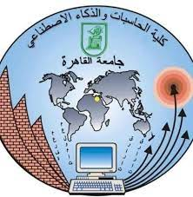 Cairo University**

**Web Technology**

**IS231**

***Phase 1***

***Dr.Neamat***

**Project Name: Human Resources Website**

**Project Number: 1**

**Name: Mohamed Fathi Sayed Abbas**

**ID: 20210348**

**Name: Abdelrahman Mohamed Ahmed Abdullah**

**ID: 20210229**

**Name: Moaz Adly Afifi Adly**

**ID: 20210402**

**Name: Mohamed Mahmoud Hussein**

**ID: 20210355**

**Name: Mostafa Ahmed Mohamed Elsawy**

**ID: 20210388**